**TASK 1**

**Project Title: Academic Management System**

**Project Description:**

Design and develop an Academic Management System using SQL. The projects should involve three tables 1.StudentInfo 2. CoursesInfo 3.EnrollmentInfo. The Aim is to create a system that allows for managing student information and course enrollment.

**Github Link-** [**https://github.com/Dishikamehndiratta/Academic-Management-System/blob/main/README.md**](https://github.com/Dishikamehndiratta/Academic-Management-System/blob/main/README.md)

1. **Database creation  
   Code-** CREATE DATABASE AcademicManagementSystem;

USE AcademicManagementSystem;

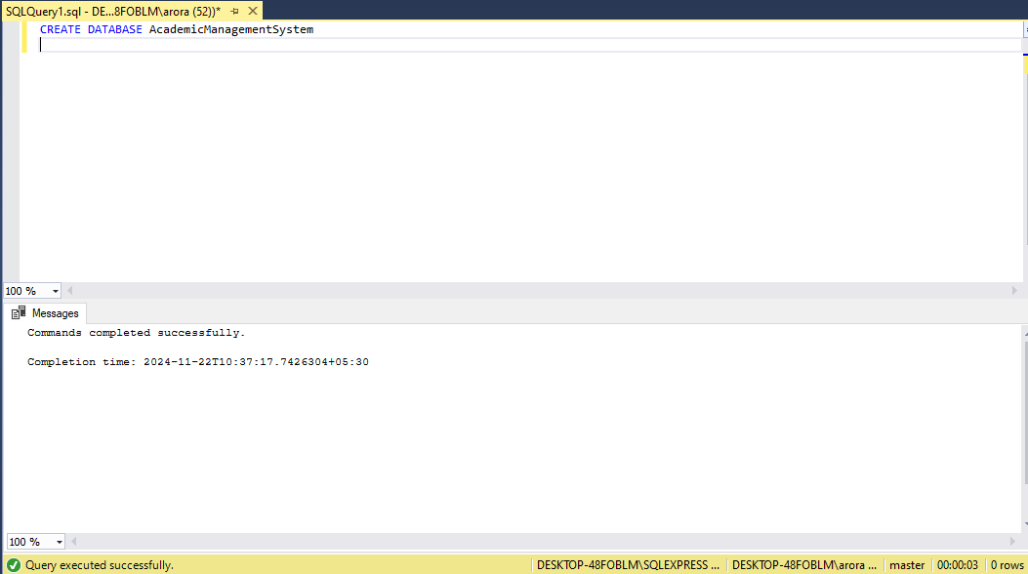

1. **Creation of Tables**

**Code-** CREATE TABLE StudentInfo (

STU_ID INT PRIMARY KEY IDENTITY(1,1),

STU_NAME VARCHAR(100) NOT NULL,

DOB DATE NOT NULL,

PHONE_NO VARCHAR(15) NOT NULL,

EMAIL_ID VARCHAR(100) NOT NULL UNIQUE,

ADDRESS VARCHAR(255)

);

CREATE TABLE CoursesInfo (

COURSE_ID INT PRIMARY KEY IDENTITY(1,1),

COURSE_NAME VARCHAR(100) NOT NULL,

COURSE_INSTRUCTOR_NAME VARCHAR(100) NOT NULL

);

CREATE TABLE EnrollmentInfo (

ENROLLMENT_ID INT PRIMARY KEY IDENTITY(1,1),

STU_ID INT NOT NULL,

COURSE_ID INT NOT NULL,

ENROLL_STATUS VARCHAR(20) NOT NULL CHECK (ENROLL_STATUS IN ('Enrolled', 'Not Enrolled')),

FOREIGN KEY (STU_ID) REFERENCES StudentInfo(STU_ID),

FOREIGN KEY (COURSE_ID) REFERENCES CoursesInfo(COURSE_ID)

);

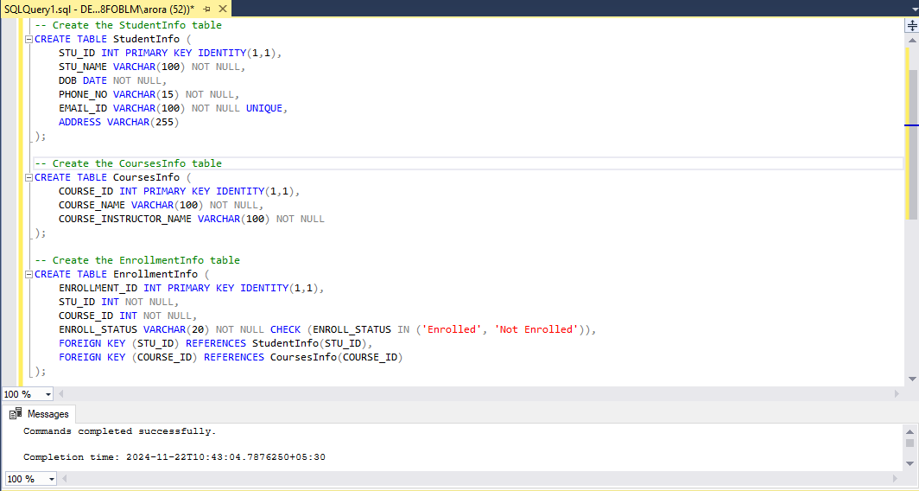

1. **Inserting Values**

**Code-** INSERT INTO StudentInfo (STU_NAME, DOB, PHONE_NO, EMAIL_ID, ADDRESS)

VALUES

('John Doe', '2000-05-15', '1234567890', 'johndoe@example.com', '123 Main Street, City A'),('Jane Smith', '1998-08-22', '9876543210', 'janesmith@example.com', '456 Elm Street, City B'),('Alice Johnson', '2001-03-10', '5551234567', 'alicej@example.com', '789 Oak Street, City C');

INSERT INTO CoursesInfo (COURSE_NAME, COURSE_INSTRUCTOR_NAME)

VALUES

('Database Systems', 'Dr. James Carter'),

('Data Structures', 'Dr. Emily Davis'),

('Software Engineering', 'Dr. Robert Brown');

INSERT INTO EnrollmentInfo (STU_ID, COURSE_ID, ENROLL_STATUS)

VALUES

(1, 1, 'Enrolled'),

(2, 2, 'Enrolled'),

(3, 3, 'Not Enrolled'),

(1, 3, 'Enrolled'); (1, 3, 'Enrolled');

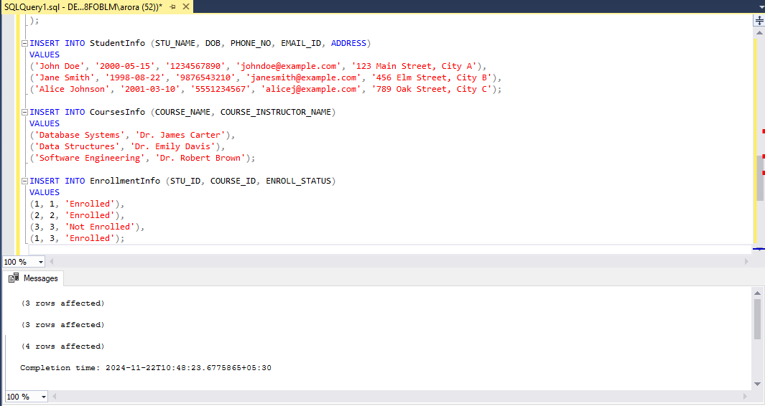

1. **Retrieve the Student Information**

**a) Write a query to retrieve student details, such as student name, contact informations, and Enrollment status.**

**CODE-** SELECT s.STU_NAME AS StudentName,

s.PHONE_NO AS ContactNumber,

s.EMAIL_ID AS Email,

e.ENROLL_STATUS AS EnrollmentStatus

FROM

StudentInfo s

JOIN

EnrollmentInfo e

ON

s.STU_ID = e.STU_ID;

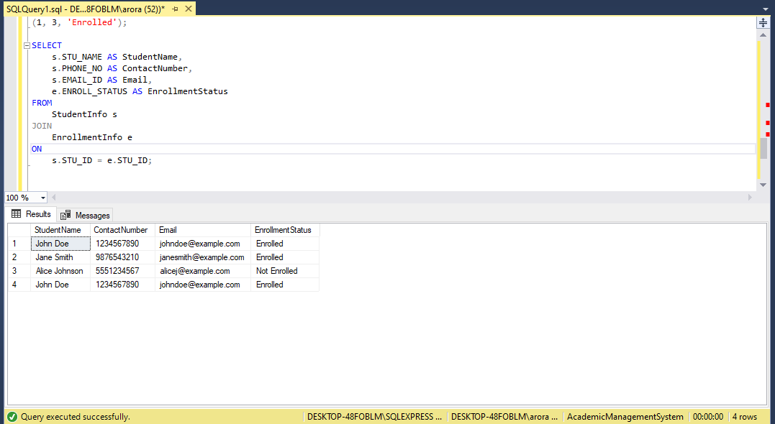

**b) Write a query to retrieve a list of courses in which a specific student is enrolled.**

**Code-**  c.COURSE_NAME AS CourseName,

c.COURSE_INSTRUCTOR_NAME AS InstructorName,

e.ENROLL_STATUS AS EnrollmentStatus

FROM

CoursesInfo c

JOIN

EnrollmentInfo e

ON

c.COURSE_ID = e.COURSE_ID

JOIN

StudentInfo s

ON

s.STU_ID = e.STU_ID

WHERE

s.STU_NAME = 'John Doe' AND e.ENROLL_STATUS = 'Enrolled';

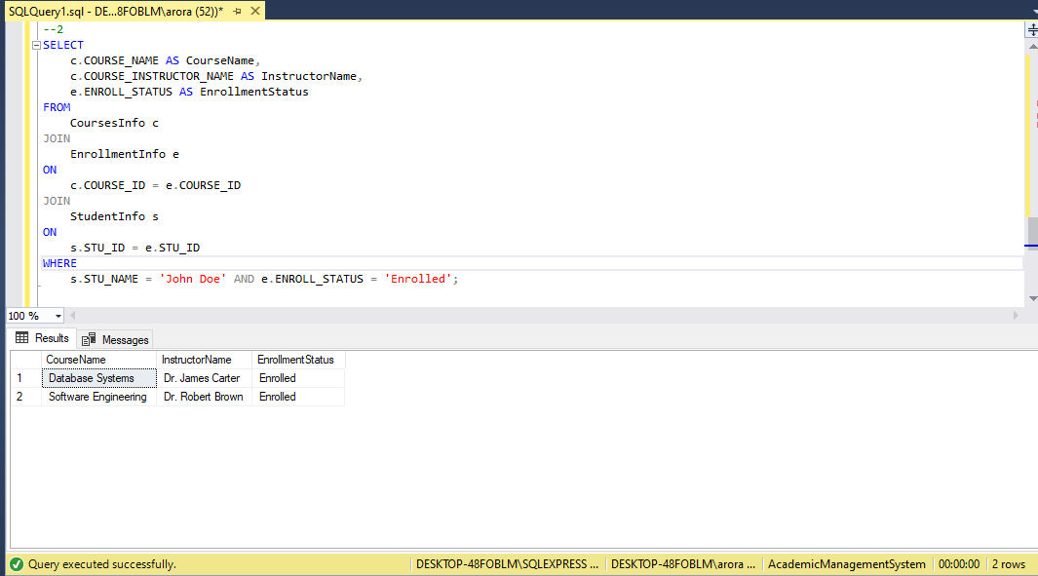

**c) Write a query to retrieve course information, including course name, instructor information.**

**Code-** SELECT

COURSE_NAME AS Course_Name,

COURSE_INSTRUCTOR_NAME AS Instructor_Name

FROM

CoursesInfo;

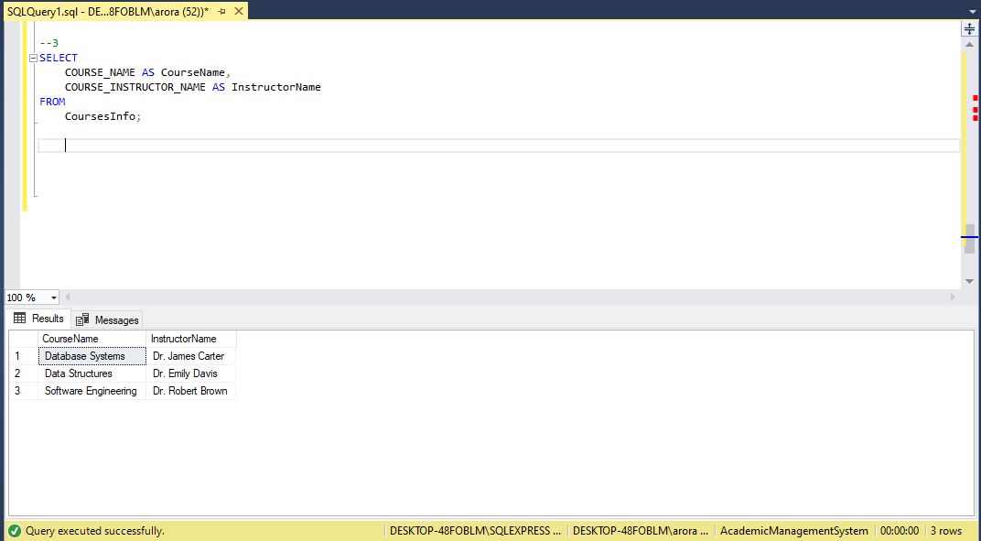

**d) Write a query to retrieve course information for a specific course .**

**Code-** SELECT

COURSE_NAME AS CourseName,

COURSE_INSTRUCTOR_NAME AS InstructorName

FROM

CoursesInfo

WHERE

COURSE_NAME = 'Database Systems';

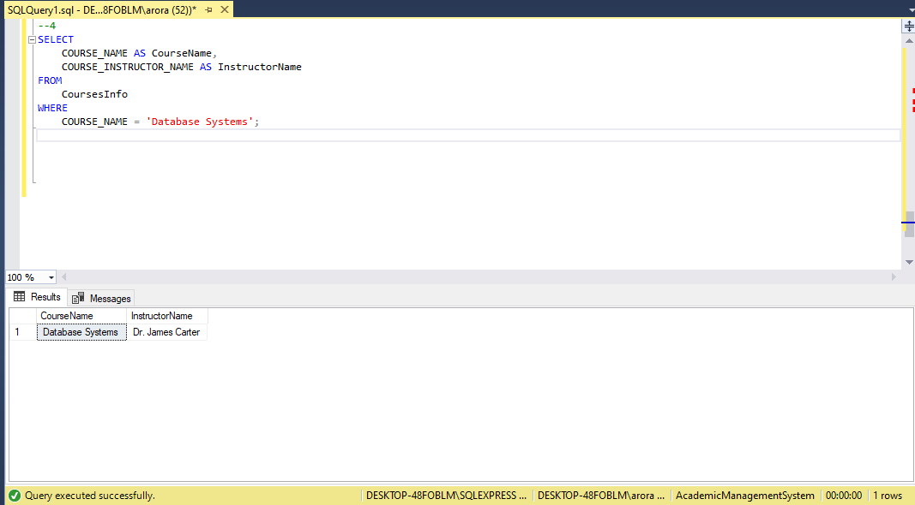

**e) Write a query to retrieve course information for multiple courses.**

**Code-** SELECT

COURSE_NAME AS CourseName,

COURSE_INSTRUCTOR_NAME AS InstructorName

FROM

CoursesInfo

WHERE

COURSE_NAME IN ('Database Systems', 'Data Structures', 'Software Engineering');

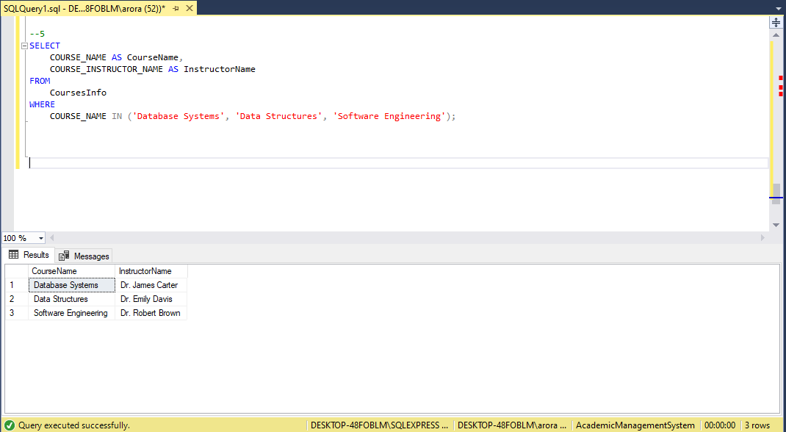

**5.Reporting and Analytics (Using joining queries)**

**a) Write a query to retrieve the number of students enrolled in each course**

**Code-** SELECT

c.COURSE_NAME AS CourseName,

COUNT(e.STU_ID) AS EnrolledStudents

FROM

CoursesInfo c

LEFT JOIN

EnrollmentInfo e

ON

c.COURSE_ID = e.COURSE_ID

WHERE

e.ENROLL_STATUS = 'Enrolled'

GROUP BY

c.COURSE_NAME;

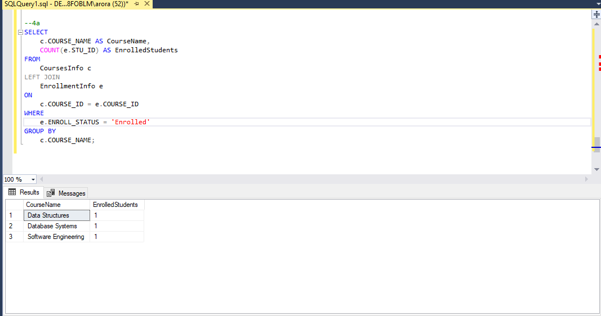

**b) Write a query to retrieve the list of students enrolled in a specific course**

**Code-** SELECT

s.STU_NAME AS StudentName,

s.PHONE_NO AS ContactNumber,

s.EMAIL_ID AS Email

FROM

StudentInfo s

JOIN

EnrollmentInfo e

ON

s.STU_ID = e.STU_ID

JOIN

CoursesInfo c

ON

e.COURSE_ID = c.COURSE_ID

WHERE

c.COURSE_NAME = 'Database Systems' AND e.ENROLL_STATUS = 'Enrolled';

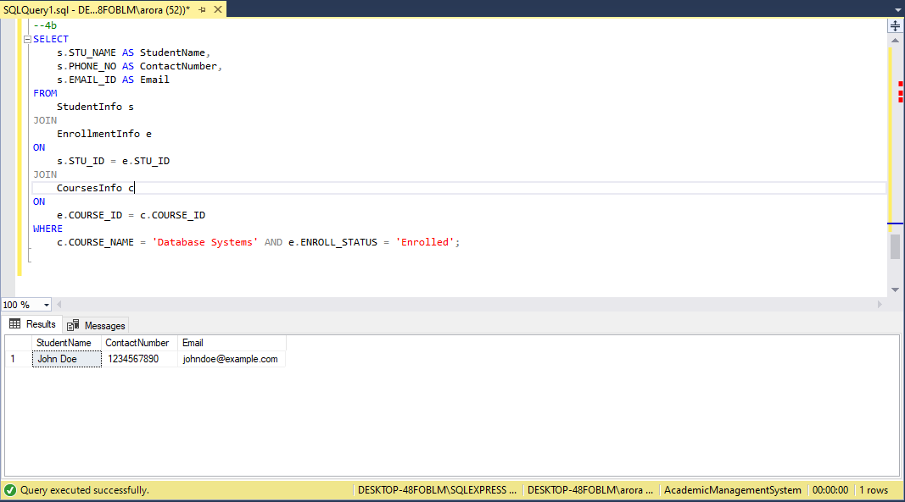

**c) Write a query to retrieve the count of enrolled students for each instructor.**

**Code-** SELECT

c.COURSE_INSTRUCTOR_NAME AS InstructorName,

COUNT(e.STU_ID) AS EnrolledStudents

FROM

CoursesInfo c

JOIN

EnrollmentInfo e

ON

c.COURSE_ID = e.COURSE_ID

WHERE

e.ENROLL_STATUS = 'Enrolled'

GROUP BY

c.COURSE_INSTRUCTOR_NAME;

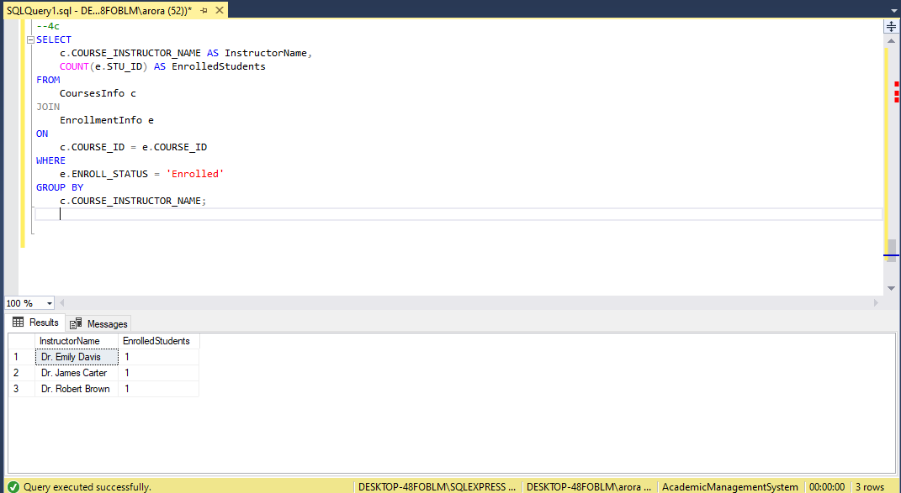

**d) Write a query to retrieve the list of students who are enrolled in multiple courses**

**Code**- SELECT

s.STU_NAME AS StudentName,

s.PHONE_NO AS ContactNumber,

s.EMAIL_ID AS Email,

COUNT(e.COURSE_ID) AS NumberOfCourses

FROM

StudentInfo s

JOIN

EnrollmentInfo e

ON

s.STU_ID = e.STU_ID

WHERE

e.ENROLL_STATUS = 'Enrolled'

GROUP BY

s.STU_NAME, s.PHONE_NO, s.EMAIL_ID

HAVING

COUNT(e.COURSE_ID) > 1;

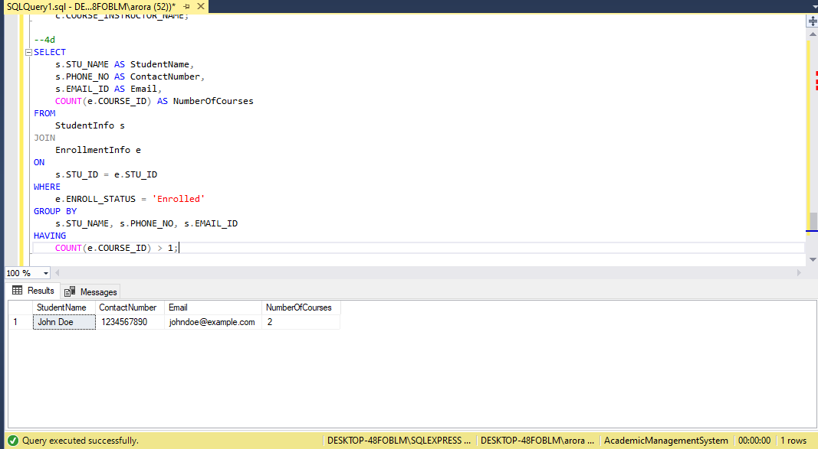

**e) Write a query to retrieve the courses that have the highest number of enrolled students (arranging from highest to lowest)**

**Code-** SELECT

c.COURSE_NAME AS CourseName,

c.COURSE_INSTRUCTOR_NAME AS InstructorName,

COUNT(e.STU_ID) AS EnrolledStudents

FROM

CoursesInfo c

JOIN

EnrollmentInfo e

ON

c.COURSE_ID = e.COURSE_ID

WHERE

e.ENROLL_STATUS = 'Enrolled'

GROUP BY

c.COURSE_NAME, c.COURSE_INSTRUCTOR_NAME

ORDER BY

EnrolledStudents DESC;

